

Avalance forecasting using Machine LEarning

[ Bhyri Chinna Venkata Prem Sai]



[Date]

[ Smart Bridge pvt ltd ]

**AVALANCHE DETECTION USING MACHINE LEARNING**

**Project Report**

-Submitted By:

Prem Sai Bhyri

**Contents**:

|  |  |  |  |  |  |  |  |  |  |  |
| --- | --- | --- | --- | --- | --- | --- | --- | --- | --- | --- |
|  | **INTRODUCTION** | | | |  | | |  |  | |
|  | 1.1 Overview | | | |  | | |  |  | |
|  | 1.2 Purpose | | | |  | | |  |  | |
|  | **LITERATURE SURVEY** | | | |  | | |  |  | |
|  | 2.1 Existing Problem | | | | | | |  |  | |
|  | 2.2 Proposed Solution | | | | | | |  |  | |
|  | **THEORITICAL ANALYSIS** | | | |  | | |  |  | |
|  | 3.1 Block Diagram | | | |  | | |  |  | |
|  | 3.2 Software Designing | | | | | | |  |  | |
|  | **EXPERIMENTAL INVESTIGATIONS** | | | | | | |  |  | |
|  | **FLOWCHART** | | | |  | | |  |  | |
|  | **RESULT** | |  | |  | | |  |  | |
|  | **ADVANTAGES & DISADVANTAGES** | | | | | | |  |  | |
|  | **APPLICATIONS** | | | |  | | |  |  | |
|  | **CONCLUSION** | | | |  | | |  |  | |
|  | **FUTURE SCOPE** | | | | **`** | | |  |  | |
|  | **BIBILOGRAPHY** | | | |  | | |  |  | |
|  | **APPENDIX** | | | |  | | |  |  | |
| Scource Code | |  | |  | |  |  | | |

**Abstract:**

Until the early 2000's, the avalanche photodiode (APD) was widely deployed in high-performance optical receivers that operated up to 10 Gb/s. In subsequent years, the use of APDs for high-capacity systems declined as a result of their limited gain bandwidth, the transition to coherent detection, and the development of high-efficiency modulation techniques. Recently, the rapid growth of optical-fiber communications systems that utilize baud rates up to 25 Gb/s represented by a 100-Gb/s Ethernet has led to a resurgence of research on APDs and the development of low-noise APDs with enhanced gain bandwidth. This paper presents a brief review of APD fundamentals and describes some of the recent advances.

**INTRODUCTION**:

**Overview of the Project:**

This project prevent the people from the avalanche by priory informing them there is a chance to the occurrence of avalanche or not. The model gets the data from the IOT based sensors. After that we want to process those data using a suitable algorithm, then our model display whether the avalanche occur or not and how strength it was.

**Purpose:**

To analyse the data coming from different sensors we are applying various machine learning algorithms. If there is a chance of avalanche then the notification will be sent to people so that they can take decisions accordingly

**LITERATURE SURVEY:**

**Existing Problem:**

“**Avalanche Problem:**” ​A​ ​set​ ​of​ ​4​ ​factors​ ​(type,​ ​location,​ ​likelihood,​ ​size)​ ​whose  
combination​ ​describes​ ​the​ ​avalanche​ ​hazard

* Avalanche Character or Type – One of 9 potential avalanche descriptions
* Location – Where the avalanche is most likely to exist in the terrain, shown with an Aspect/Elevation diagram
* Likelihood – The chance of triggering an avalanche
* Size – The destructive potential of the expected avalanche

Types of Avalanche Problems

## [**Loose Dry**](http://avalanche.state.co.us/forecasts/help/avalanche-problems/loose-dry/)

[](http://avalanche.state.co.us/wp-content/uploads/2013/12/Loose.Dry_.png)

Release of dry unconsolidated snow. These avalanches typically occur within layers of soft snow near the surface of the snowpack. Loose-dry avalanches start at a point and entrain snow as they move downhill, forming a fan-shaped avalanche. Other names for loose-dry avalanches include *point-release avalanches* or *sluffs*. Loose-dry avalanches can trigger slab avalanches that break into deeper snow layers.

Loose Dry avalanches are usually relatively harmless to people. They can be hazardous if you are caught and carried into or over a terrain trap (e.g. gully, rocks, dense timber, cliff, crevasse) or down a long slope. Avoid traveling in or above terrain traps when Loose Dry avalanches are likely.

## [**Storm Slab**](http://avalanche.state.co.us/forecasts/help/avalanche-problems/storm-slab/)

[](http://avalanche.state.co.us/wp-content/uploads/2013/12/Storm.Slabs_.png)

Release of a soft cohesive layer (a slab) of new snow that breaks within the storm snow or on the old snow surface. Storm-slab problems typically last between a few hours and few days. Storm-slabs that form over a persistent weak layer (surface hoar, depth hoar, or near-surface facets) may be termed Persistent Slabs or may develop into Persistent Slabs.

You can reduce your risk from Storm Slabs by waiting a day or two after a storm before venturing into steep terrain. Storm slabs are most dangerous on slopes with terrain traps, such as timber, gullies, over cliffs, or terrain features that make it difficult for a rider to escape off the side.

## [**Wind Slab**](http://avalanche.state.co.us/forecasts/help/avalanche-problems/wind-slab/)

[](http://avalanche.state.co.us/wp-content/uploads/2013/12/Wind.Slabs_.png)

Release of a cohesive layer of snow (a slab) formed by the wind. Wind typically transports snow from the upwind sides of terrain features and deposits snow on the downwind side. Wind slabs are often smooth and rounded and sometimes sound hollow, and can range from soft to hard. Wind slabs that form over a persistent weak layer (surface hoar, depth hoar, or near-surface facets) may be termed Persistent Slabs or may develop into Persistent Slabs.

Wind Slabs form in specific areas, and are confined to lee and cross-loaded terrain features. They can be avoided by sticking to sheltered or wind-scoured areas.

## [**Persistent Slab**](http://avalanche.state.co.us/forecasts/help/avalanche-problems/persistent-slab/)

[](http://avalanche.state.co.us/wp-content/uploads/2013/12/Persistent.Slabs_.png)

Release of a cohesive layer of soft to hard snow (a slab) in the middle to upper snowpack, when the bond to an underlying persistent weak layer breaks. Persistent layers include: surface hoar, depth hoar, near-surface facets, or faceted snow. Persistent weak layers can continue to produce avalanches for days, weeks or even months, making them especially dangerous and tricky. As additional snow and wind events build a thicker slab on top of the persistent weak layer, this avalanche problem may develop into a Deep Persistent Slab.

The best ways to manage the risk from Persistent Slabs is to make conservative terrain choices. They can be triggered by light loads and weeks after the last storm. The slabs often propagate in surprising and unpredictable ways. This makes this problem difficult to predict and manage and requires a wide safety buffer to handle the uncertainty

## [**Deep Persistent Slab**](http://avalanche.state.co.us/forecasts/help/avalanche-problems/deep-persistent-slab/)

[](http://avalanche.state.co.us/wp-content/uploads/2013/12/Deep.Persistent.Slabs_.png)

Release of a thick cohesive layer of hard snow (a slab), when the bond breaks between the slab and an underlying persistent weak layer, deep in the snowpack or near the ground. The most common persistent weak layers involved in deep, persistent slabs are depth hoar or facets surrounding a deeply buried crust. Deep Persistent Slabs are typically hard to trigger, are very destructive and dangerous due to the large mass of snow involved, and can persist for months once developed. They are often triggered from areas where the snow is shallow and weak, and are particularly difficult to forecast for and manage. They commonly develop when Persistent Slabs become more deeply buried over time.

Deep Persistent Slabs are destructive and deadly events that can take

## [**Loose Wet**](http://avalanche.state.co.us/forecasts/help/avalanche-problems/loose-wet/)

[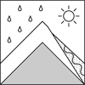](http://avalanche.state.co.us/wp-content/uploads/2013/12/Loose.Wet_.png)

Release of wet unconsolidated snow or slush. These avalanches typically occur within layers of wet snow near the surface of the snowpack, but they may quickly gouge into lower snowpack layers. Like Loose Dry Avalanches, they start at a point and entrain snow as they move downhill, forming a fan-shaped avalanche. They generally move slowly, but can contain enough mass to cause significant damage to trees, cars or buildings. Other names for loose-wet avalanches include point-release avalanches or sluffs. Loose Wet avalanches can trigger slab avalanches that break into deeper snow layers.Travel when the snow surface is colder and stronger. Plan your trips to avoid crossing on or under very steep slopes in the afternoon. Move to colder, shadier slopes once the snow surface turns slushly. Avoid steep, sunlit slopes above terrain traps, cliffs areas and long sustained steep pitches.

## [**Cornice Fall**](http://avalanche.state.co.us/forecasts/help/avalanche-problems/cornice-fall/)

[](http://avalanche.state.co.us/wp-content/uploads/2013/12/Cornice.png)

Cornice Fall is the release of an overhanging mass of snow that forms as the wind moves snow over a sharp terrain feature, such as a ridge, and deposits snow on the downwind (leeward) side. Cornices range in size from small wind lips of soft snow to large overhangs of hard snow that are 30 feet (10 meters) or taller. They can break off the terrain suddenly and pull back onto the ridge top and catch people by surprise even on the flat ground above the slope. Even small cornices can have enough mass to be destructive and deadly. Cornice Fall can entrain loose surface snow or trigger slab avalanches.

Cornices can never be trusted and avoiding them is necessary for safe backcountry travel. Stay well back from ridge line areas with cornices. They often overhang the ridge edge can be triggered remotely. Avoid areas underneath cornices. Even small Cornice Fall can trigger a larger avalanche and large Cornice Fall can easily crush a human. Periods of significant temperature warm-up are times to be particularly aware.

## [**Glide**](http://avalanche.state.co.us/forecasts/help/avalanche-problems/glide/)

[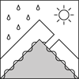](http://avalanche.state.co.us/wp-content/uploads/2013/12/Glide.png)

Release of the entire snow cover as a result of gliding over the ground. Glide avalanches can be composed of wet, moist, or almost entirely dry snow. They typically occur in very specific paths, where the slope is steep enough and the ground surface is relatively smooth. The are often proceeded by full depth cracks (glide cracks), though the time between the appearance of a crack and an avalanche can vary between seconds and months. Glide avalanches are unlikely to be triggered by a person, are nearly impossible to forecast, and thus pose a hazard that is extremely difficult to manage.

Predicting the release of Glide Avalanches is very challenging. Because Glide Avalanches only occur on very specific slopes, safe travel relies on identifying and avoiding those slopes. Glide cracks are a significant indicator, as are recent Glide Avalanches.

**Proposed Solution:**

**Prevention and Mitigation**

Although various classification schemes are possible,avalanche prevention measures can be divided into structural and non-structural measures. The former consist mainly of organizational measures such as daily avalanche hazard bulletans and artificial realease of avalanches. The latter includes technical measures like defence sturctures and forests

**THEORITICAL ANALYSIS:**

**Block Diagram:**

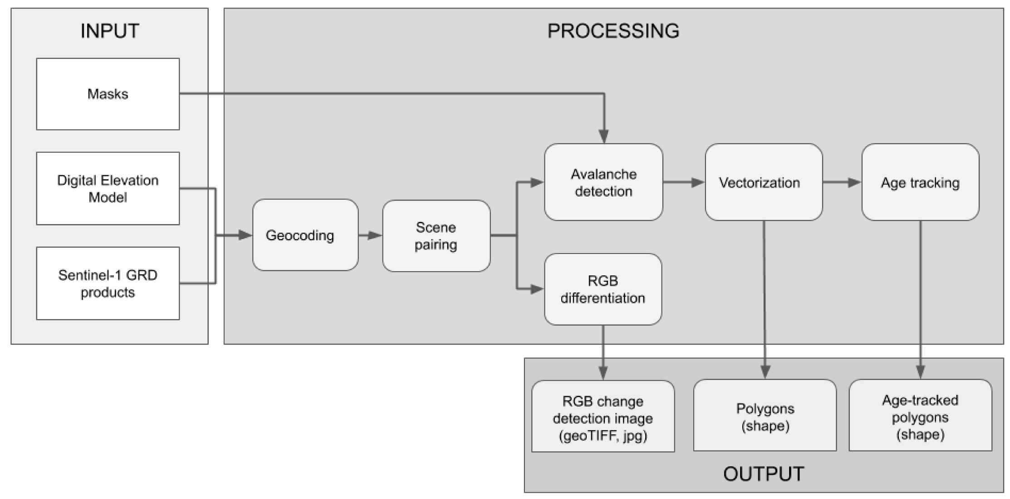

**Software Designing:**

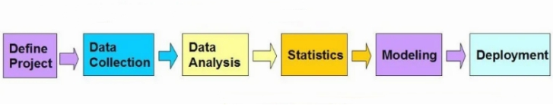

i) Define Project:

Define the project outcomes, deliverables, scoping of the effort, bussines objectives, identify the data sets which are going to be used.

ii) Data Collection:

Data Mining for predictive analysis prepares data from multiple sources for analysis. This provides a complete view of the customer interactions.

iii) Data Preprocessing:

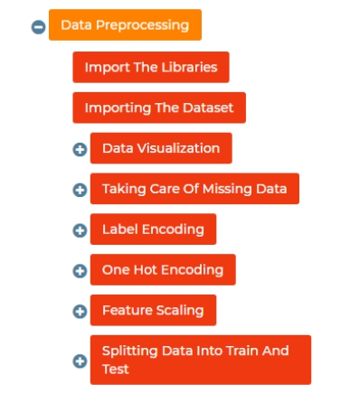

It is the process of inspecting, cleaning, transforming, and modeling data with the objective of discovering useful information, arriving at conclutions.

iv) Statistics:

It enables to validate the assumptions, hypotheses and test them with using standard statistical models.

v) Modeling:

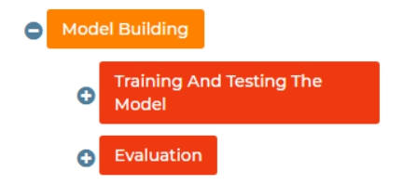

Predictive Modeling provides the ability to automatically create accurate predictive models about future. There are also options to choose the best solution with multi model evalution.

vi) Deployment:

Predictive Model Deployment provies the option to deploy the analytical results in to the every day decision making process to get results, reports and output by automating the decisions based on the modeling.

vii) Model Monitoring:

Models are managed and monitored to review the model performance to ensure that it is providing the results expected

viii) Web Reporting:

To view the result the web reporting is done, Online project reports makers often use graphs, images, and charts to visually present useful information such as project status, length of activity, and time spent doing each task. These reports are easy to interpret, making them an ideal way of communicating the latest updates to all consumers.

**EXPERIMENTAL INVESTIGATIONS:**

**FLOWCHART:**

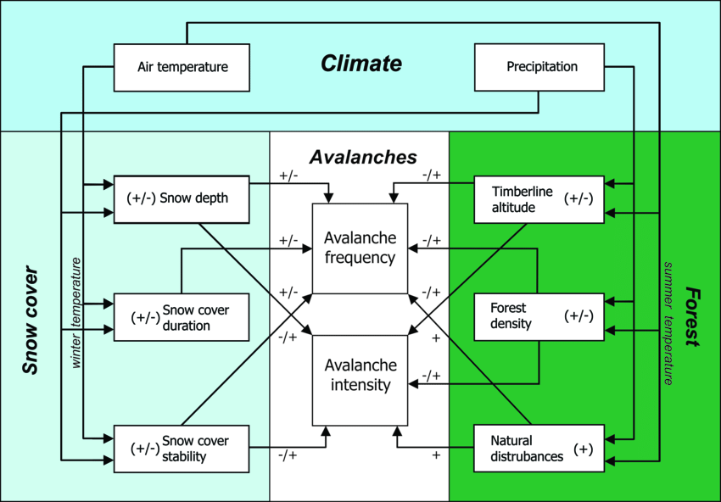

**RESULT:**

We got an accuracy of 87% which is good measure for Avalanche Forecasting using Machine Learning.

The Model predicts the stage with good efficiency.

**Conclusion**

In the above, the various aspects involved in the prediction of avalanches were mentioned and suggestions given as to what is needed to improve upon the present status.

The difference in predicting avalanches that threaten residential areas versus what is needed for avalanche forecasts for recreational users and what needs to be included in the two different types of prediction was discussed.

The importance of the estimation of runout was discussed and an example given as to the use of such an estimate in predicting the possible extent of avalanches. Within that scope a suggestion was made as to the response in light of such a prediction.

A rundown of the necessary instrumentation in aid of avalanche prediction was discussed and the observation made as to the inadequacy of present sensors. The modelling effort was reviewed and a suggestion for further and closer collaboration between the various avalanche institutes was made. A recommendation was put forward to the European Union as to put an emphasis on projects that can provide solutions to the problems at hand. It must provide support to the institutes that have been focusing on these problems, some of them for a long time. The scope of the projects must take into account what is feasible to accomplish and concentrate on taking small but secure steps towards a better understanding of the problem of predicting avalanches. It is not possible within one project to supply all the solutions to all the problems. It is better to take smaller steps and let each project rest on the shoulders of the previous one and to ensure that concurrent projects do not overlap excessively but at the same time advocate consultation among the various projects.

Finally the importance of an effective snow observer network is discussed and that everything must be done to ensure the well being of such a network.